[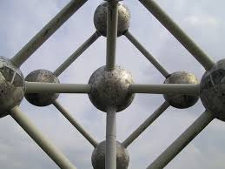](http://www.google.nl/imgres?imgurl=https://bartgoos.files.wordpress.com/2010/10/symmetrie.jpg&imgrefurl=https://bartgoos.wordpress.com/&h=480&w=640&tbnid=-P4rnf2yhHGroM:&zoom=1&docid=7_fjoshmsdh06M&ei=OB32VMveGofrUqqYg0A&tbm=isch&ved=0CIwBEDMoTTBN)[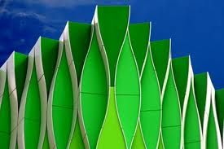](http://www.google.nl/imgres?imgurl=http://static.zoom.nl/EFBA80ACE2489821D5827A8CF5AE3D47-groningen--umc.jpg&imgrefurl=http://zoom.nl/artikel/community/20605-portfolioreview-met-henk-siteur.html&h=266&w=400&tbnid=e9Tvtj_1gTUroM:&zoom=1&docid=IbwqqobpcUf9uM&ei=YB32VOupI8KqU5nvguAF&tbm=isch&ved=0CEwQMyhEMEQ4ZA)

[](http://www.google.nl/imgres?imgurl=http://static.skynetblogs.be/media/127668/dyn009_original_1024_766_pjpeg_2625365_defc6f5387fb056b75845f9a861934e6.jpg&imgrefurl=http://po-lokaal.skynetblogs.be/tag/symmetrie&h=766&w=1024&tbnid=C-fiUuYweLF2NM:&zoom=1&docid=-A_VP876C7LpeM&ei=YB32VOupI8KqU5nvguAF&tbm=isch&ved=0CDMQMygrMCs4ZA)

Symmetrische Compositie